**ARDUINO DUE**

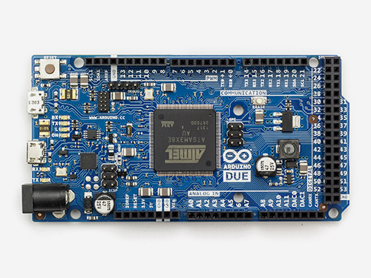

|  |
| --- |
|  |
| Microcontroller | AT91SAM3X8E |
| Operating Voltage | 3.3V |
| Input Voltage (recommended) | 7-12V |
| Input Voltage (limits) | 6-16V |
| Digital I/O Pins | 54 (12 provide PWM output) |
| Analog Input Pins | 12 |
| Analog Output Pins | 2 (DAC) |
| Total DC Output Current on all I/O lines | 130 mA |
| DC Current for 3.3V Pin | 800 mA |
| DC Current for 5V Pin | 800 mA |
| Flash Memory | 512 KB all available for the user applications |
| SRAM | 96 KB (two banks: 64KB and 32KB) |
| Clock Speed | 84 MHz |
| Length | 101.52 mm |
| Width | 53.3 mm |
| Weight | 36 g |

